Search:

UVRI

UGANDA VIRUS RESEARCH INSTITUTE
WELCOME TO UVRI
HOW IS YOUR HEALTH?
Report an outbreak

Studying the viruses that shape public health in East Africa.
The Uganda Virus Research Institute is a country’s national reference laboratory for viral disease, supporting the Ministry of Health with surveillance, diagnostics, and research into arboviral diseases, viral haemorrhagic fevers, HIV, and emerging pathogens.
Contact info:
Nakiwogo Road, Entebbe
info@uvri.example.ug
© 2026 Uganda Virus Research Institute

Phone: Call 03308085456(open Monday-Friday 8am-4pm
View Current Advisories

Explore Research Programs
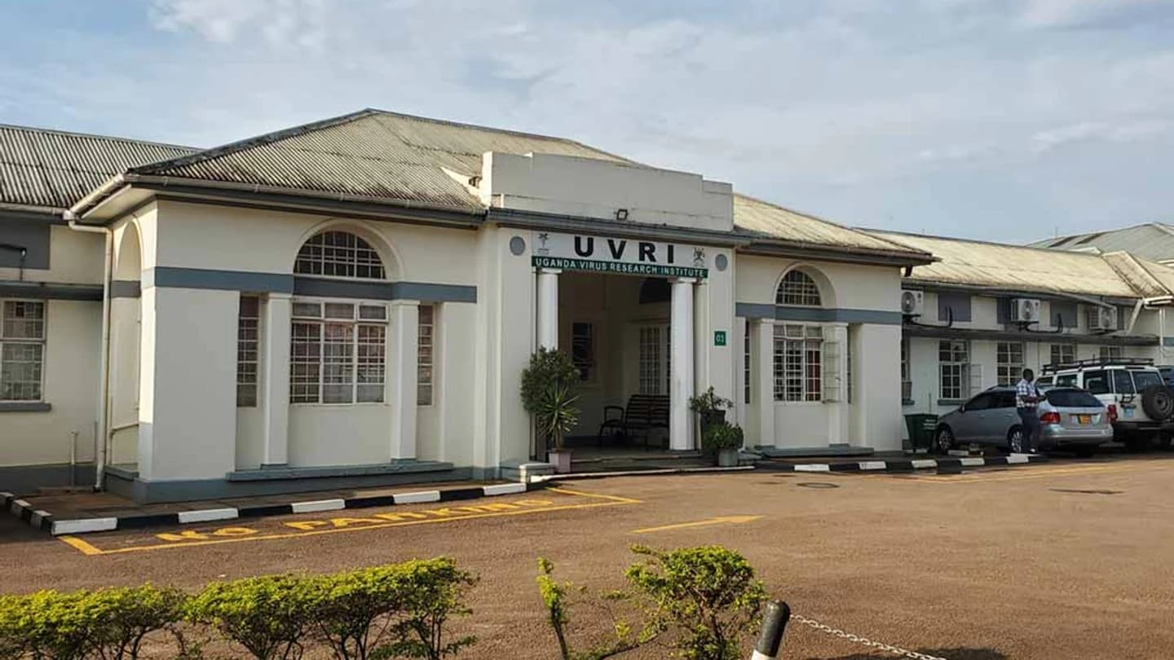

About Us
Institute Record
- Founded | 1937
- Location | Entebbe, Uganda
- Oversight | Ministry of Health
- Designation | WHO Collaborating Centre

PROJECT BRIEF
Vision: To be a world-class center of excellence in viral and health research
Mission &Core Objectives
Scientific Investigation: Conduct robust research on viral and other communicable diseases.
Knowledge &Innovation: Contribute to scientific knowledge, innovations, and evidence-based health policy and practice.
Capacity Strengthening: Build institutional sustainability, train scientists, and develop regional public health capacity.
Core Values
Research Ethics: Operating strictly in line with established scientific and institutional research ethics.
Public Interests: Prioritizing community welfare and health needs.
Collective Efforts: Rooting long-term success in mutual trust, teamwork, and shared institutional goals.


OUR SERVICES

Viral Haemorrhagic Fevers
Surveillance and rapid diagnostic response for Ebola, Marburg, and related haemorrhagic fever outbreaks.
Arboviral Diseases
Long-standing research into yellow fever, Zika, dengue, and other mosquito-and tick-borne viruses.
HIV &Emerging Pathogens
Molecular epidemiology and clinical research supporting national and regional HIV response, and monitoring for newly emerging viral threats.
Uganda's national reference institute for viral disease research, diagnostics, and outbreak response, based in Entebbe.




GALLERY PAGE







CONTACT US@:

Contact Details
- Email: directoruvri@uvri.go.org
- info@uvri.example.ug
- © 2026 Uganda Virus Research Institute
- Phone: +256-414-320385 / +256-414-320386
- Address: Plot 51-59 Nakiwogo Road, P.O. Box 49, Entebbe, Uganda
- Hours: Monday to Friday, 8:00 AM to 5:00 PM

Site
- Home
- About Us
- Services/products
- Gallery page
- Contact Us Page
Programs
- Viral Haemorrhagic Fevers
- Arbovirology
- HIV Research

